Tables and figures

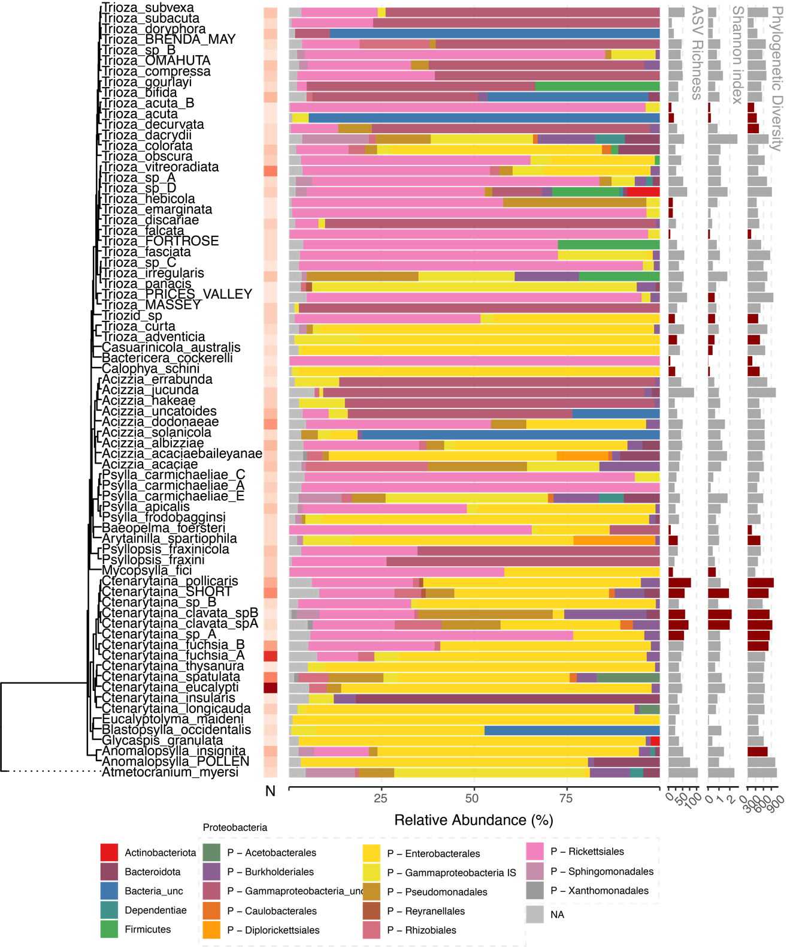

**Figure 2:** Overview of microbiome results by species

**Figure 3:** Phylosymbiosis – Results of Mantel tests (**A**), partial Mantel tests (**B**), and beta diversity through time analysis (**C**).

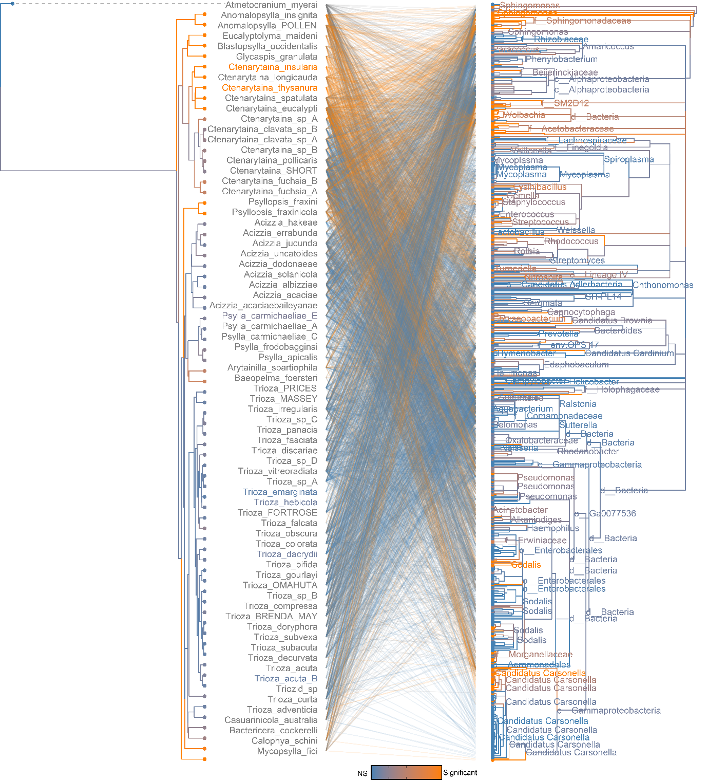

**Figure 4:** Phylogenetic congruence between psyllid species and microbiome. Links and taxa coloured according to their contribution to PACo global fit.

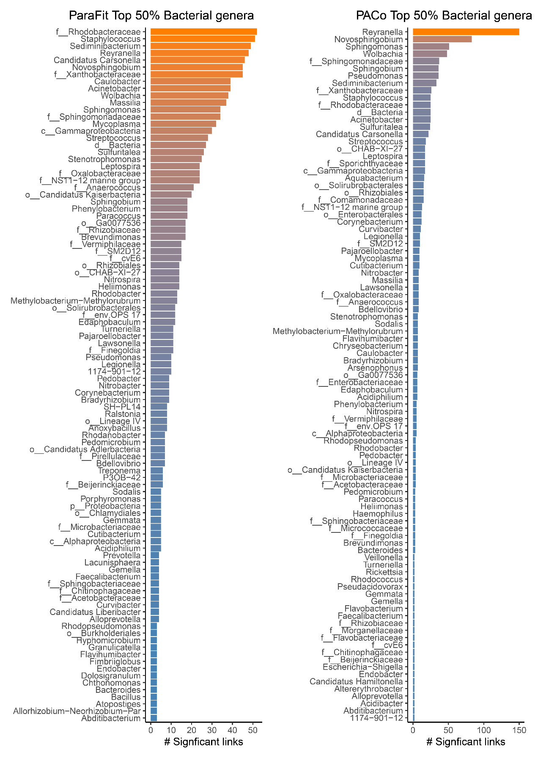

**Figure 5:** Number of significant links from each microbial genus contributing to phylogenetic congruence between psyllid species and their microbiome for both ParaFit and PACo

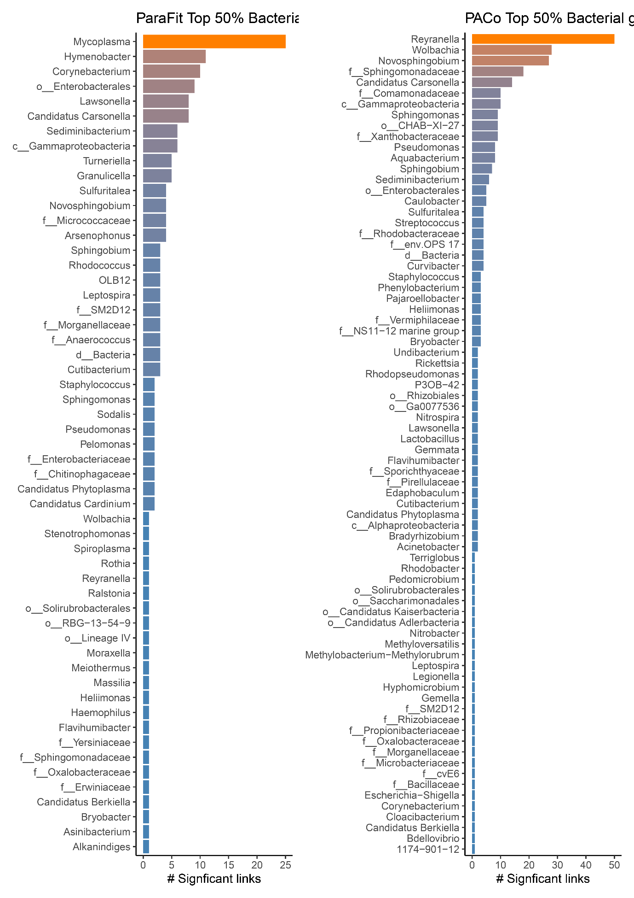**Figure 6:** Number of significant links from each microbial genus contributing to phylogenetic congruence between Trioza species and their microbiome for both ParaFit and PACo

# Supplementary information

**EXTRA: Collection locations of NZ psyllid samples**

**Supplementary Figure 1a:** Rarefaction curves showing sequencing depth for each sample. All samples below 1000 sequence reads were removed.

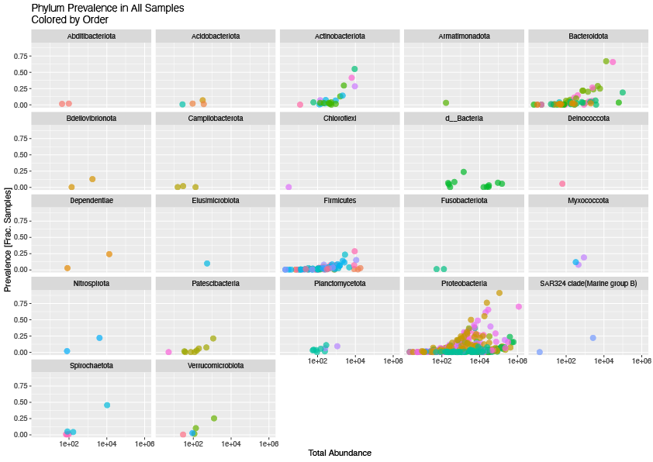

**Supplementary Figure 1b:** Abundance and prevalence of different bacterial phyla across the entire dataset after filtering.

**Supplementary Figure 2A:** PCA plot of Aitchison distance between microbial communities coloured by psyllid phylogenetic cluster.

**Supplementary Figure 2B:** PCA plot of Aitchison distance between microbial communities coloured by hostplant phylogenetic cluster.

**Supplementary Figure 2C:** PCA plot of Aitchison distance between microbial communities coloured by cluster membership following UPGMA on great circle distance between collection locations.

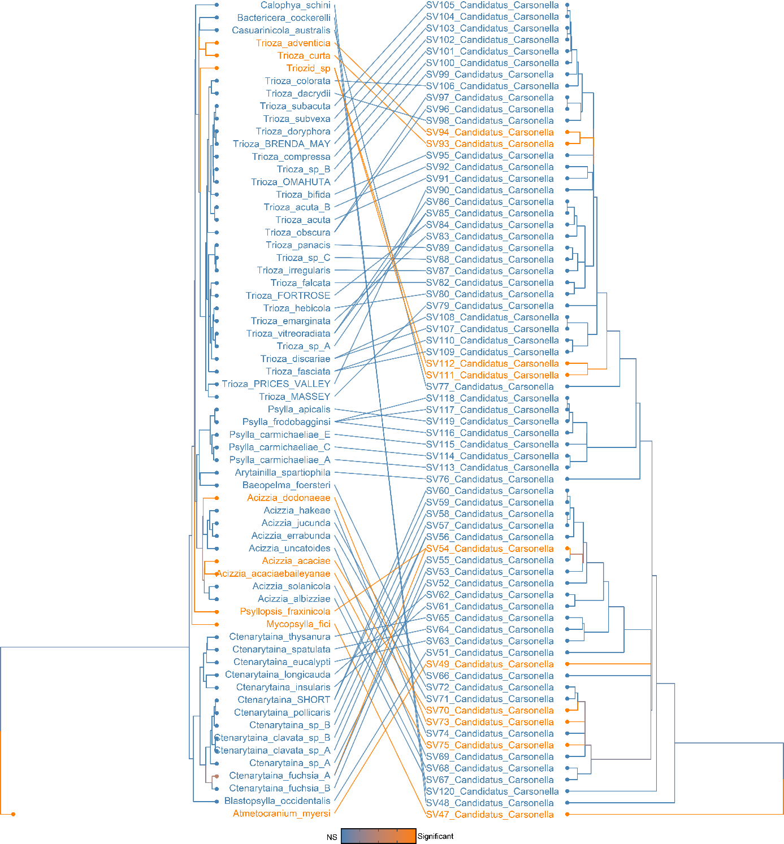

**Supplementary Figure 3:** Phylogenetic congruence between psyllid species and Candidatus Carsonella ASVs. Links and taxa coloured according to their contribution to PACo global fit.

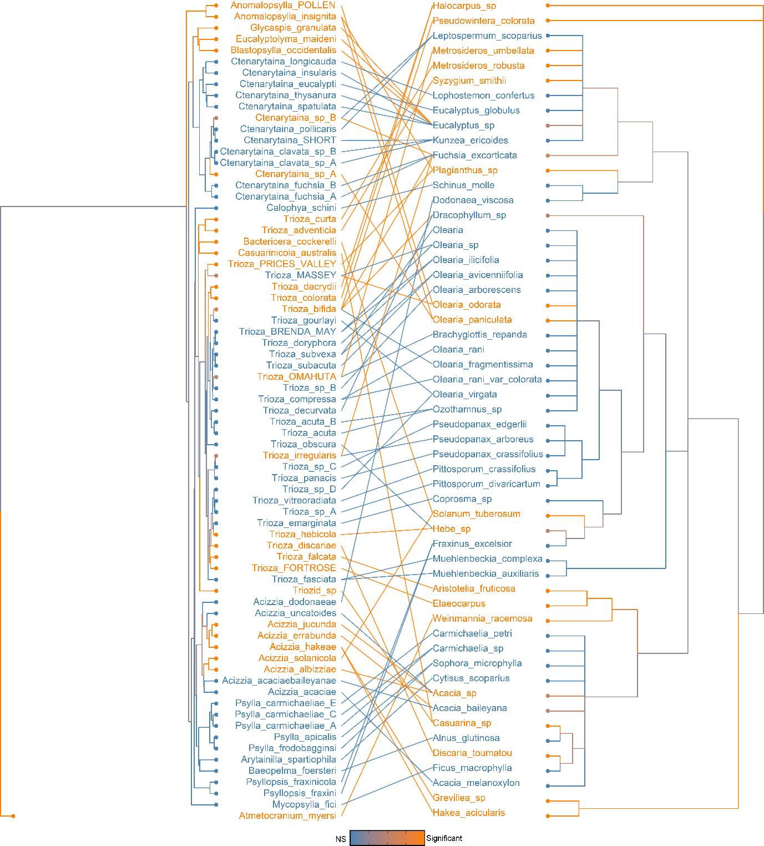

**Supplementary Figure 4**: Phylogenetic congruence between psyllid species and hostplant species. Links and taxa coloured according to their contribution to PACo global fit.

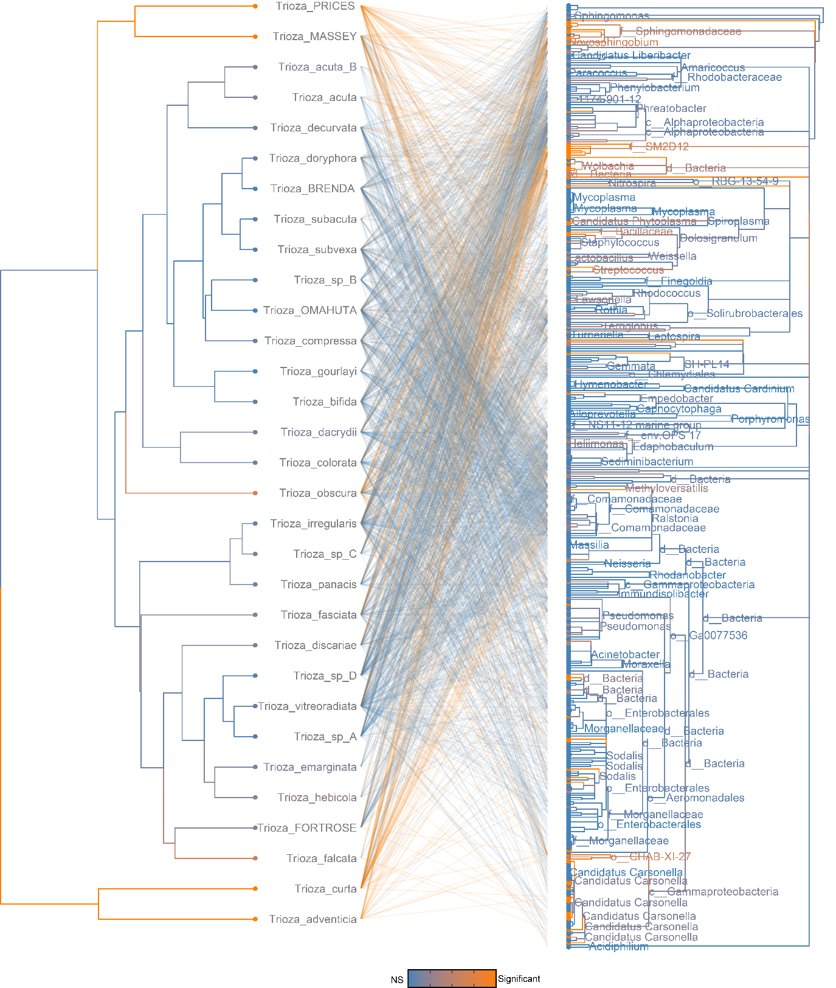

**Supplementary Figure 5:** Phylogenetic congruence between *Trioza* species and their microbiome. Links and taxa coloured according to their contribution to PACo global fit.

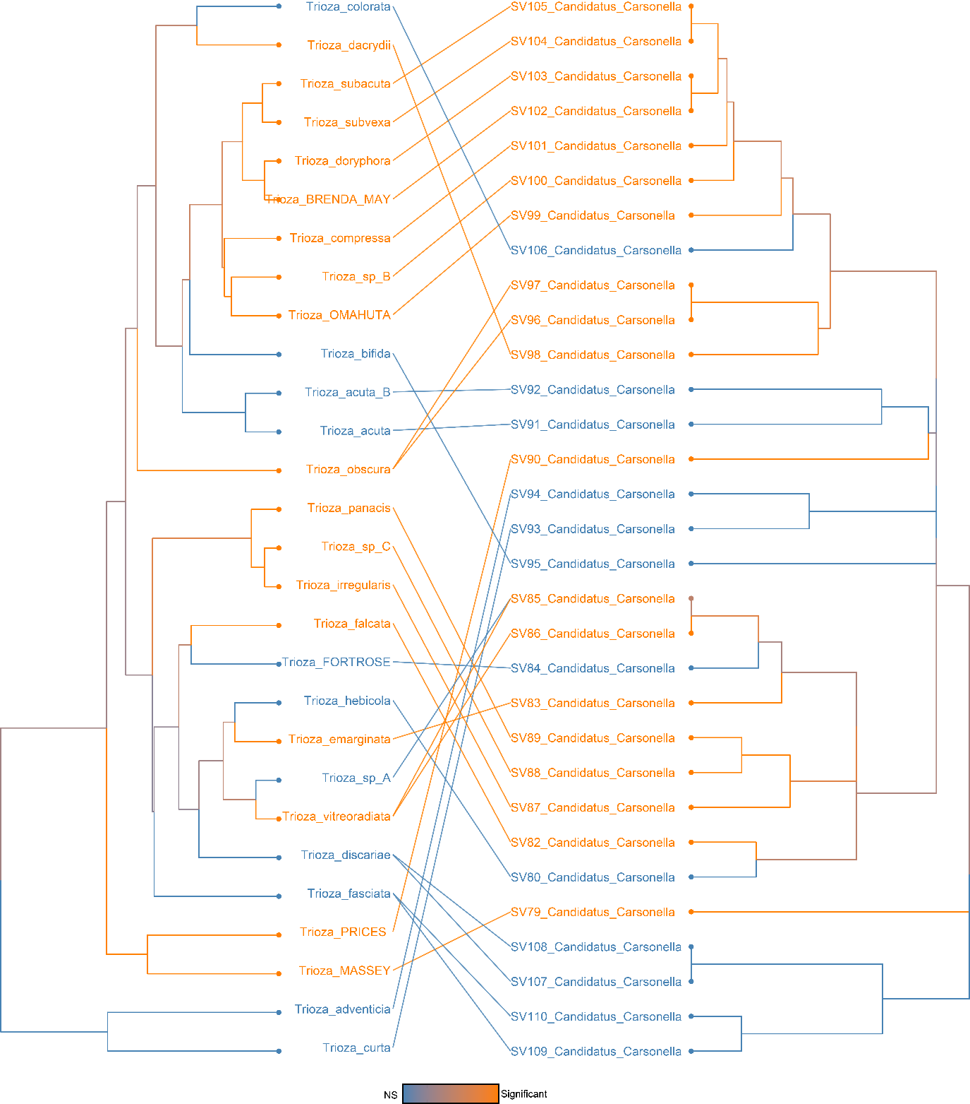

**Supplementary Figure 6:** Phylogenetic congruence between Trioza species and Candidatus Carsonella ASVs. Links and taxa coloured according to their contribution to PACo global fit.

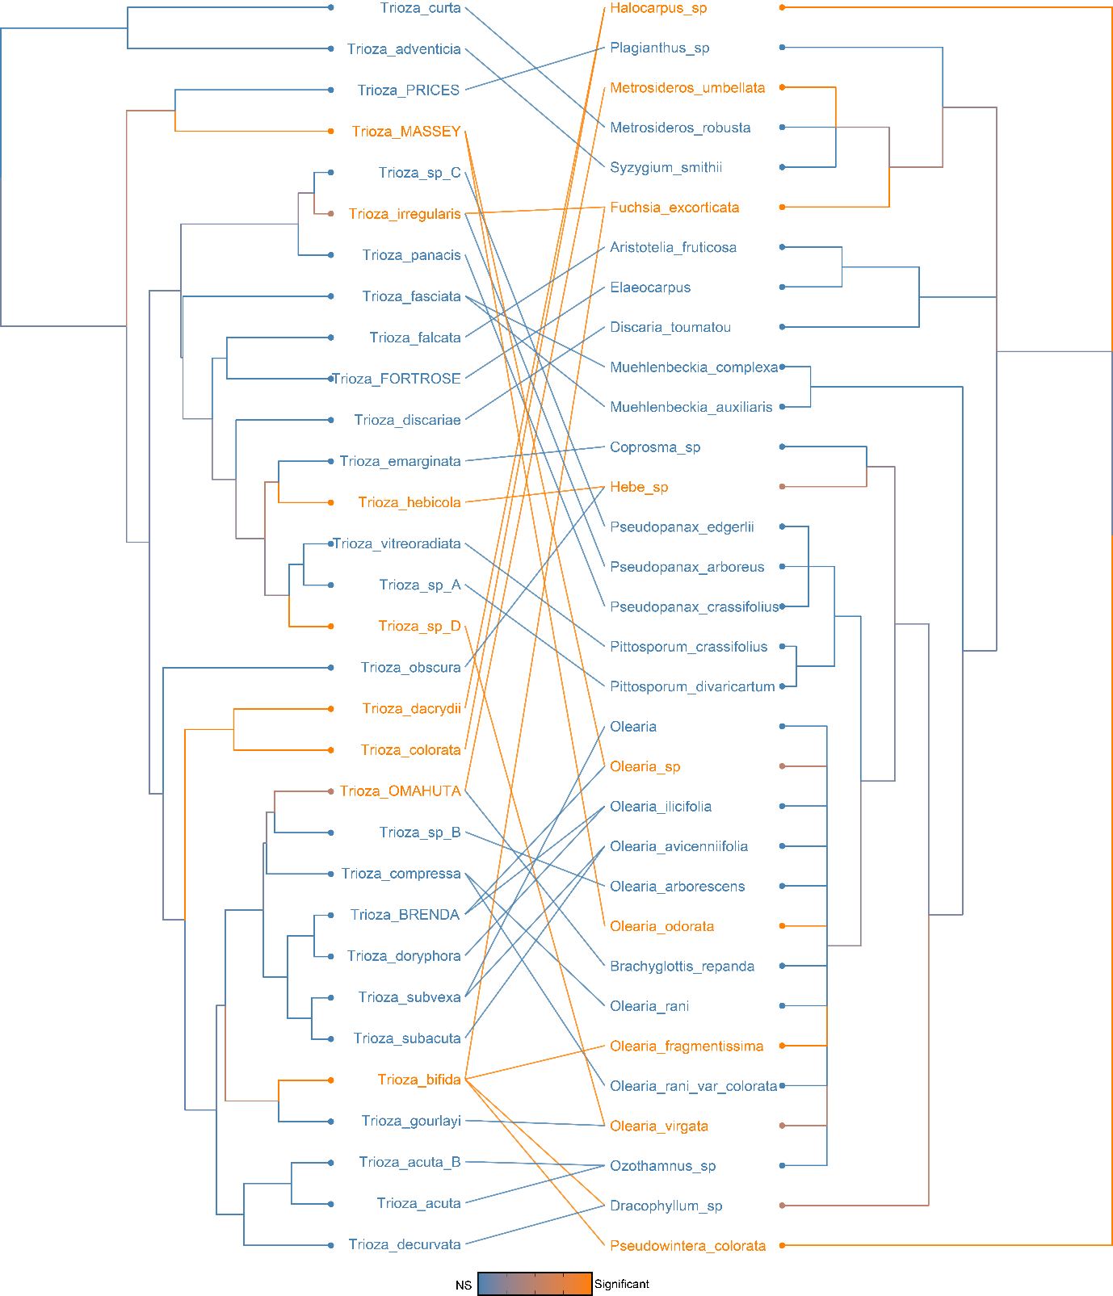

**Supplementary Figure 7:** Phylogenetic congruence between Trioza species and hostplant species. Links and taxa coloured according to their contribution to PACo global fit.

**Adonis results for different distance measures.** Note that the R2 values are always higher for psyllids phylogeny compared to hostplant.

|  |  |  |  |  |  |  |  |
| --- | --- | --- | --- | --- | --- | --- | --- |
| ­ | **term** | **df** | **SumsOfSqs** | **MeanSqs** | **F.Model** | **R2** | **p.value** |
| **Bray** | psyllid_spp | 74 | 75.9719275 | 1.02664767 | 4.49700625 | 0.65279035 | 0.001 |
| **Bray** | hostplant_spp | 55 | 54.5869929 | 0.99249078 | 3.14804707 | 0.46903986 | 0.001 |
| **Jaccard** | psyllid_spp | 74 | 43.4323434 | 0.58692356 | 2.04770318 | 0.46123647 | 0.001 |
| **Jaccard** | hostplant_spp | 55 | 32.9151396 | 0.59845708 | 1.9150663 | 0.3495474 | 0.001 |
| **Aitchison** | psyllid_spp | 74 | 142965.303 | 1931.96356 | 2.19311858 | 0.47832357 | 0.001 |
| **Aitchison** | hostplant_spp | 55 | 108585.661 | 1974.28475 | 2.03339208 | 0.36329851 | 0.001 |
| **Unifrac** | psyllid_spp | 74 | 25.7110859 | 0.34744711 | 2.01199508 | 0.45686801 | 0.001 |
| **Unifrac** | hostplant_spp | 55 | 20.3455383 | 0.36991888 | 2.01785367 | 0.36152598 | 0.001 |
| **WUnifrac** | psyllid_spp | 74 | 25.7206748 | 0.34757669 | 5.3239992 | 0.69000445 | 0.001 |
| **WUnifrac** | hostplant_spp | 55 | 20.412656 | 0.3711392 | 4.31366712 | 0.54760708 | 0.001 |

**Mantel results for different distance measures**

|  |  |  |  |  |  |
| --- | --- | --- | --- | --- | --- |
| **dist** | **mantelr** | **pval** | **llim.2.5%** | **ulim.97.5%** | **dist1** |
| **Bray** | 0.18157003 | 0.001 | 0.16818337 | 0.22324658 | phylo.dist |
| **Bray** | 0.18921805 | 0.001 | 0.17482358 | 0.20832634 | plant.dist |
| **Bray** | 0.09517944 | 0.001 | 0.0825982 | 0.1080083 | spat.dist |
| **Jaccard** | 0.04946199 | 0.072 | 0.036153 | 0.08002391 | phylo.dist |
| **Jaccard** | 0.13591112 | 0.001 | 0.11255801 | 0.15800243 | plant.dist |
| **Jaccard** | 0.02287177 | 0.436 | 0.00238033 | 0.045936 | spat.dist |
| **Aitchison** | 0.22976035 | 0.001 | 0.15992586 | 0.25201626 | phylo.dist |
| **Aitchison** | 0.04756532 | 0.156 | 0.02038544 | 0.07000935 | plant.dist |
| **Aitchison** | 0.04123014 | 0.429 | 0.00338496 | 0.0788697 | spat.dist |
| **Unifrac** | 0.0578 | 0.078 | 0.0464187 | 0.07798872 | phylo.dist |
| **Unifrac** | 0.12409659 | 0.001 | 0.10298463 | 0.14371115 | plant.dist |
| **Unifrac** | 0.00937781 | 0.805 | -0.007235 | 0.02648686 | spat.dist |
| **WUnifrac** | 0.08395321 | 0.026 | 0.06615729 | 0.09472239 | phylo.dist |
| **WUnifrac** | 0.09855466 | 0.001 | 0.07975156 | 0.11531844 | plant.dist |
| **WUnifrac** | -0.0577221 | 0.129 | -0.068447 | -0.0421818 | spat.dist |

**Partial mantel results for different distance measures**

|  |  |  |  |  |  |  |  |
| --- | --- | --- | --- | --- | --- | --- | --- |
| **dist** | **mantelr** | **pval** | **llim.2.5%** | **ulim.97.5%** | **dist1** | **dist2** | **dist3** |
| **Bray** | 0.13411929 | 0.001 | 0.12223275 | 0.16200041 | phylo.dist | plant.dist | spat.dist |
| **Bray** | 0.10493659 | 0.001 | 0.09449539 | 0.11547555 | spat.dist | phylo.dist | plant.dist |
| **Bray** | 0.1523537 | 0.001 | 0.1331613 | 0.17044173 | plant.dist | spat.dist | phylo.dist |
| **Jaccard** | 0.01076958 | 0.722 | 4.06E-05 | 0.03349455 | phylo.dist | plant.dist | spat.dist |
| **Jaccard** | 0.03001003 | 0.32 | 0.00920232 | 0.05010296 | spat.dist | phylo.dist | plant.dist |
| **Jaccard** | 0.12876763 | 0.001 | 0.107261 | 0.14463066 | plant.dist | spat.dist | phylo.dist |
| **Aitchison** | 0.22504417 | 0.001 | 0.14889203 | 0.24836672 | phylo.dist | plant.dist | spat.dist |
| **Aitchison** | 0.03957756 | 0.475 | 0.00228897 | 0.07970439 | spat.dist | phylo.dist | plant.dist |
| **Aitchison** | -0.0166416 | 0.66 | -0.0474116 | 0.00697877 | plant.dist | spat.dist | phylo.dist |
| **Unifrac** | 0.02337332 | 0.512 | 0.01444681 | 0.03792453 | phylo.dist | plant.dist | spat.dist |
| **Unifrac** | 0.01543671 | 0.658 | -0.0019277 | 0.03447449 | spat.dist | phylo.dist | plant.dist |
| **Unifrac** | 0.11319137 | 0.001 | 0.09170898 | 0.13328527 | plant.dist | spat.dist | phylo.dist |
| **WUnifrac** | 0.06000782 | 0.091 | 0.03684844 | 0.06989536 | phylo.dist | plant.dist | spat.dist |
| **WUnifrac** | -0.0543991 | 0.147 | -0.0653216 | -0.0395205 | spat.dist | phylo.dist | plant.dist |
| **WUnifrac** | 0.07514953 | 0.008 | 0.05857711 | 0.09637918 | plant.dist | spat.dist | phylo.dist |

**Adonis results – repeated after removing all Gammaproteobacteria**

|  |  |  |  |  |  |  |  |
| --- | --- | --- | --- | --- | --- | --- | --- |
| **dist** | **term** | **df** | **SumsOfSqs** | **MeanSqs** | **F.Model** | **R2** | **p.value** |
| Bray | psyllid_spp | 74 | 56.2319176 | 0.75989078 | 2.55442109 | 0.51642933 | 0.001 |
| Bray | hostplant_spp | 55 | 40.8846547 | 0.74335736 | 2.14257626 | 0.37548132 | 0.001 |
| Jaccard | psyllid_spp | 74 | 39.4183321 | 0.53268016 | 1.76508244 | 0.42460749 | 0.001 |
| Jaccard | hostplant_spp | 55 | 30.2606138 | 0.55019298 | 1.72336084 | 0.32596212 | 0.001 |
| Aitchison | psyllid_spp | 74 | 53131.3574 | 717.991316 | 2.01192424 | 0.45685927 | 0.001 |
| Aitchison | hostplant_spp | 55 | 40202.5091 | 730.954711 | 1.8827532 | 0.34568831 | 0.001 |
| Unifrac | psyllid_spp | 74 | 27.3303761 | 0.36932941 | 1.87192149 | 0.43902519 | 0.001 |
| Unifrac | hostplant_spp | 55 | 21.4381932 | 0.38978533 | 1.87184593 | 0.34437532 | 0.001 |
| WUnifrac | psyllid_spp | 74 | 44.7501597 | 0.60473189 | 3.52677772 | 0.59587339 | 0.001 |
| WUnifrac | hostplant_spp | 55 | 33.2964558 | 0.60539011 | 2.83842287 | 0.44336092 | 0.001 |

**Mantel results –** **repeated after removing all Gammaproteobacteria**

|  |  |  |  |  |  |
| --- | --- | --- | --- | --- | --- |
| dist | mantelr | pval3 | llim.2.5% | ulim.97.5% | dist1 |
| Bray | 0.10173472 | 0.001 | 0.09201224 | 0.1176122 | phylo.dist |
| Bray | 0.07645643 | 0.001 | 0.06441567 | 0.08987944 | plant.dist |
| Bray | 0.09653493 | 0.002 | 0.08178993 | 0.10992345 | spat.dist |
| Jaccard | 0.03645645 | 0.187 | 0.02358766 | 0.06218962 | phylo.dist |
| Jaccard | 0.12640614 | 0.001 | 0.10635685 | 0.14563726 | plant.dist |
| Jaccard | 0.02559136 | 0.395 | 0.00438016 | 0.04697594 | spat.dist |
| Aitchison | 0.20948266 | 0.001 | 0.14641777 | 0.23061167 | phylo.dist |
| Aitchison | 0.02414901 | 0.456 | 1.86E-04 | 0.04296708 | plant.dist |
| Aitchison | 0.06152691 | 0.256 | 0.02348832 | 0.08935163 | spat.dist |
| Unifrac | 0.03015174 | 0.395 | 0.01846147 | 0.04835 | phylo.dist |
| Unifrac | 0.11288769 | 0.001 | 0.09217884 | 0.13477319 | plant.dist |
| Unifrac | 0.00385297 | 0.926 | -0.0165861 | 0.02090566 | spat.dist |
| WUnifrac | 0.09073475 | 0.001 | 0.08066551 | 0.10155848 | phylo.dist |
| WUnifrac | 0.05882365 | 0.008 | 0.04310485 | 0.07589714 | plant.dist |
| WUnifrac | 0.11339481 | 0.001 | 0.09604389 | 0.12953364 | spat.dist |

**Partial mantel – repeated after removing all Gammaproteobacteria**

|  |  |  |  |  |  |  |  |
| --- | --- | --- | --- | --- | --- | --- | --- |
| dist | mantelr | pval3 | llim.2.5% | ulim.97.5% | dist1 | dist2 | dist3 |
| Bray | 0.08179899 | 0.001 | 0.07196513 | 0.09433957 | phylo.dist | plant.dist | spat.dist |
| Bray | 0.09936836 | 0.001 | 0.08502017 | 0.11450454 | spat.dist | phylo.dist | plant.dist |
| Bray | 0.05567498 | 0.012 | 0.04057298 | 0.06855663 | plant.dist | spat.dist | phylo.dist |
| Jaccard | -1.42E-04 | 0.998 | -0.0103766 | 0.01664303 | phylo.dist | plant.dist | spat.dist |
| Jaccard | 0.03246953 | 0.278 | 0.01111876 | 0.05395916 | spat.dist | phylo.dist | plant.dist |
| Jaccard | 0.12278456 | 0.001 | 0.1037497 | 0.14295823 | plant.dist | spat.dist | phylo.dist |
| Aitchison | 0.21038406 | 0.002 | 0.14867445 | 0.23540317 | phylo.dist | plant.dist | spat.dist |
| Aitchison | 0.05930987 | 0.233 | 0.02892096 | 0.08613387 | spat.dist | phylo.dist | plant.dist |
| Aitchison | -0.034298 | 0.345 | -0.064394 | -0.0148972 | plant.dist | spat.dist | phylo.dist |
| Unifrac | -0.0022051 | 0.952 | -0.0120048 | 0.01022506 | phylo.dist | plant.dist | spat.dist |
| Unifrac | 0.00985356 | 0.815 | -0.0098981 | 0.0288481 | spat.dist | phylo.dist | plant.dist |
| Unifrac | 0.10923405 | 0.001 | 0.08943142 | 0.1282031 | plant.dist | spat.dist | phylo.dist |
| WUnifrac | 0.07515898 | 0.016 | 0.06345529 | 0.08680397 | phylo.dist | plant.dist | spat.dist |
| WUnifrac | 0.1153887 | 0.002 | 0.10134501 | 0.13202448 | spat.dist | phylo.dist | plant.dist |
| WUnifrac | 0.04136585 | 0.09 | 0.02314086 | 0.05837275 | plant.dist | spat.dist | phylo.dist |